Mini Project Report
on
CV MAKER

Submitted to
Ajay Kumar Garg Engineering College, Ghaziabad

(BTech Information Technology Sem 3rd, 2020-21)
(KSC-354 Project Mini Project or Internship Assessment Report)

Submitted To: - Submitted By:
Mr. Sumit Sharma Sushank Pathak
(1900270110055)

Subhdeep Kushwah
(1900270110051)

ACKNOWLEDGEMENT

It is our privilege to express our sincere regards to our project coordinator, Mr. Sumit Sharma for their valuable inputs, able guidance, encouragement, whole –hearted cooperation and constructive criticism throughout the duration of our project. We deeply express our sincere thanks to our Head of Department Dr. Prof. Anu Choudhary for encouraging and allowing us to present the project on the topic “CV Maker” at our department premises for the partial fulfilment of the requirements leading to the award of BTech degree. We pay our respects and love to our parents and all other family members and friends for their love and encouragement throughout our career. Last but not the least we express our thanks to our friends for their cooperation and support.

ABSTRACT

This project is developed in Java. It would be useful to simplify the task of creating individuals CV. The application is very easy to use and flexible, it reduces the need of thinking and designing an CV. The system is developed to provide an easy means for creating a professional looking CV.
The person who want to create his CV, just have to fill up a form, which contains his personal information, educational details, interest, skills etc. After filling all required fields user can print or create PDF of his CV on clicking on one button.
This is very user-friendly application which is very helpful for a user in day to day life.

TABLE OF CONTENTS
- Introduction
- Problem Statement and Description
- SRS
  - Language Used
  - Platform Used
- Working
- Use Case Diagram
- Data Flow Diagram
- CRC
- Classes
- Coding Snapshots
  - Input.java (Main)
  - Details.java (Class)
  - Print.java (Class)
- Test results
- Snapshots
INTRODUCTION

Curriculum vitae (CV) are a written overview of a person’s experience and other qualifications. In some countries, a CV is typically the first item that a potential employer encounters regarding the job seeker and is typically used to screen applicants often followed by an interview. A curriculum vitae is a more comprehensive document that details all your past education, experiences, and competencies, including public presentations, academic writing and professional development. It is designed to introduce you to employers in academics, advanced research, post-secondary teachings. Curriculum vitae is a Latin expression which can be loosely translated as the course of my life.
It is an application that simplifies the task of creating a CV for individuals. The system is flexible to be used and reduces the need of thinking and designing an appropriate CV according to qualifications. The system is developed to provide an easy means for creating a professional looking CV. Individuals just have to fill all required fields such as personal information, educational information, qualities, skills and so on. The answers provided by the users are stored and then the system asks the user for the destination for storing the generated file.
So, what does Curriculum Vitae mean? Curriculum vitae is a Latin expression which can be translated as the course of my life. So, with that in mind, it seems realistic that the outline of a modern CV still remains true to its original intent. Yes, legislation has been conceived and developed; it’s no longer standard to put your date of birth on your CV – to protect against Age Discrimination or you would no longer need to know who you are related to (from a historic age when who you were, and who you were related to, was possibly a short listing criteria!!),but the intention of a CV remains true to its original purpose. Yes, the Silver Spoon of the ‘upper classes’ still exists, but your ability, experience and skills are much more relevant than a few hundred years ago, when class played a massive part in the job that you had; if you had to have one at all! But the weird thing is – the internet – usually full of amazing facts and figures about useless facts is pretty lacking on information on the whole subject. There are some mutterings of Resumes being created by English Lords to give travellers a character reference when arriving on a distant land, but that is pretty much it!
Fast forward 400 years and it’s not till the 1950’s that CV’s are used as a matter of course in applying for job. Prior to this the CV remained a document of choice and often drafted up at interview of with an employer as a formality for being offered the job.
This is just a guess, but one would also assume that it is not until the 1950’s that applicants for a job travelled from afar and therefore the majority of applicants for a job lived local to where the job was based. Therefore, word of mouth, reputation, and past experience working in that local area would be more valuable than any CV could offer. Prior to the 1940’s, and for our UK readers, imagine ‘Downton Abbey’, you either were born rich and became educated or you were poor and had a menial job. Your CV up until that point, was the family you were born into. It was probably at the end of the Second World War in 1945 that the working classes and as importantly, Women, strived to better themselves beyond their expected ‘position’. Least not forget, that Women only gained the right to vote in the UK in 1832! What would be the point of the CV to the many, if you could only ever really achieve one type of job!
Post 1950, we have seen the introduction of the word processor, the home computer, the internet, sending CV’s by email, applying for jobs online, creating CV’s using online CV builders, and social media being used to apply for jobs or at least network about available positions.
But as much as technology advancements have enhanced the formatting and delivery of our CV, the reasoning behind the CV has changed very little. So, any predictions of the demise of the CV are slightly short-sighted! Perhaps over the next 100 years the delivery of the Curriculum Vitae will evolve somewhat. Perhaps we will not need to write a CV, as our records will be updated for us via online record keeping!?! But for the CV to go, it may mean we are returning to a time when skills, experience and education are no longer required – and that seems a future not worth the paper it is written on.

PROBLEM STATEMENT AND DESCRIPTION

Problem statement:
This CV builder is designed to help the job seekers to creates a professional CV for them. The candidates are not required to spend more time designing and creating professional cv. They can enter their details directly into the pop-up box and their CV will be created automatically.
- Why develops a CV?
CV are meant to encourage an employer or a supervisor to consider you:
- As an employee
- As a candidate for further studies.
- As the right fit for a contract.

- When to use a CV?
- Applying for work and/or contracts in academics, advanced research, post-secondary teaching and fine arts.
- Applying for graduate school, scholarships etc.
- Applying for a job.

Description:
This project is for generating a Professional CV in PDF format.
The user needs to enter all the details as required by the software and also select the destination for saving the generated CV.
CV will be generated and saved automatically.

SRS

- Requirements for the project:
  - Software requirements:
    - Operating system: Windows XP/ Windows 7/ Windows 8/ Windows 10
    - Languages: Java 1.6
    - Tools: Net Beans/ Eclipse
    - JAVA Software Development Kit
    - NetBeans IDE

Language Used: JAVA

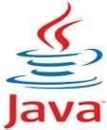
Java is a general-purpose computer programming language that is concurrent, class-based, object-oriented, and specifically designed to have as few implementation dependencies as possible. It is intended to let application developers "write once, run anywhere" (WORA),[14] meaning that compiled Java code can run on all platforms that support Java without the need for recompilation. Java applications are typically compiled to bytecode that can run on any Java virtual machine.

Java programming language was originally developed by Sun Microsystems which was initiated by James Gosling and released in 1995 as core component of Sun Microsystems' Java

platform. The latest release of the Java Standard Edition is Java SE 8. With the advancement of Java and its widespread popularity, multiple configurations were built to suite various types of platforms. Ex: J2EE for Enterprise Applications, J2ME for Mobile Applications.

Java is:

• Object Oriented: In Java, everything is an Object. Java can be easily extended since it is based on the Object model.

• Platform independent: Unlike many other programming languages including C and C++, when Java is compiled, it is not compiled into platform specific machine, rather into platform independent byte code. This byte code is distributed over the web and interpreted by virtual Machine (JVM) on whichever platform it is being run.

• Simple: Java is designed to be easy to learn. If you understand the basic concept of OOP Java would be easy to master.

• Secure: With Java's secure feature it enables to develop virus-free, tamper-free systems. Authentication techniques are based on public-key encryption.

• Architectural-neutral: Java compiler generates an architecture-neutral object file format which makes the compiled code to be executable on many processors, with the presence of Java runtime system.

• Portable: Being architectural-neutral and having no implementation dependent aspects of the specification makes Java portable. Compiler in Java is written in ANSI C with a clean portability boundary which is a POSIX subset.

• Robust: Java makes an effort to eliminate error prone situations by emphasizing mainly on compile time error checking and runtime checking.

• Multithreaded: With Java's multithreaded feature it is possible to write programs that can do many tasks simultaneously. This design feature allows developers to construct smoothly running interactive applications.

• Interpreted: Java byte code is translated on the fly to native machine instructions and is not stored anywhere. The development process is more rapid and analytical since the linking is an incremental and light weight process.

• High Performance: With the use of Just-In-Time compilers, Java enables high performance.

• Distributed: Java is designed for the distributed environment of the internet.

• Dynamic: Java is considered to be more dynamic than C or C++ since it is designed to adapt to an evolving environment. Java programs can carry extensive amount of run- time information that can be used to verify and resolve accesses to objects on run- time.

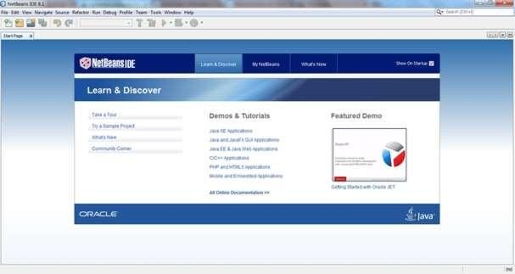
Platform Used: Netbeans

NetBeans is a Java-based integrated development environment (IDE). The term also refers to the IDE’s underlying application platform framework. The IDE is designed to limit coding errors and facilitate error correction with tools such as the NetBeans Find Bugs to locate and fix common Java coding problems and Debugger to manage complex code with field watches, breakpoints and execution monitoring. Although the NetBeans IDE is designed specifically for Java developers, it also supports C/C++, PHP, Groovy, and HTML5 in addition to Java, JavaScript and JavaFX.

Tools and capabilities of the NetBeans IDE include a feature-rich text editor with refactoring tools and code templates, high level and granular views of applications, a drag and drop GUI design, and versioning using out-of-the-box integration with tools such as Git. The NetBeans IDE can run on any operating system that supports a compatible JVM including Linux, Windows and OS X.

The underlying NetBeans platform supports creation of new applications and further development of existing applications using modular software components. As an application running on the NetBeans Platform, the NetBeans IDE itself is extensible and can be extended to support new languages.

3.5.1 Features of Netbeans:

1. Tools for Java 8 Technologies. Anyone interested in getting started with lambdas, method references, streams, and profiles in Java 8 can do so immediately by downloading NetBeans IDE 8. Java hints and code analyzers help you upgrade anonymous inner classes to lambdas, right across all your code bases, all in one go. Java hints in the Java editor let you quickly and intuitively switch from lambdas to method references, and back again.

2. Tools for JavaScript. Thanks to powerful new JavaScript libraries and frameworks over the years, JavaScript as a whole has become a lot more attractive for many developers. For some releases already, NetBeans IDE has been available as a pure frontend environment, that is, minus all the Java tools for which it is best known. This lightweight IDE, including Git versioning tools, provides a great environment for frontend devs. In particular, for users of AngularJS, Knockout, and Backbone, the IDE comes with deep editor tools, such as code completion and cross-artifact navigation.

3. Tools for HTML5. JavaScript is a central component of the HTML5 Platform, a collective term for a range of tools and technologies used in frontend development. Popular supporting technologies are Grunt, a build tool, and Karma, a test runner framework. Both of these are now supported out of the box in NetBeans IDE 8.

4. Tools for Java EE Developers. The code generators for which NetBeans IDE is well known have been beefed up significantly

WORKING
About menu option contains information about the software and its developers.
Help menu option tells the format of entering text in the tab opened currently. Help menu is different for different tabs.
Every next Tab is enabled when SUBMIT button of previous tab is clicked which in turn is enabled when all compulsory fields are filled. Once a tab is enabled it can be revisited anytime and information can be altered by submitting it again.
a) Personal Information:
The user needs to enter all the details in required format. Submit button will not be enabled until all fields are filled.

b) Educational Information:
This field is mandatory and user needs to input correct details of educational qualification.

c) Professional Education and Experience(optional):
This field is optional and asks for any specialization course and professional experience.

d) Achievements:
This field asks for academic and extra curriculum achievements if any. This is also not mandatory.

e) Projects and Skill Set:
Projects field is again not mandatory but field for skill set is compulsory to move to next step.

f) Hobbies and Interests:
This field is compulsory, User has to enter his hobbies and fields of interests.

g) Choosing Destination:
Finally choose the destination where the CV generated by the software has to be saved.

USE CASE DIAGRAM
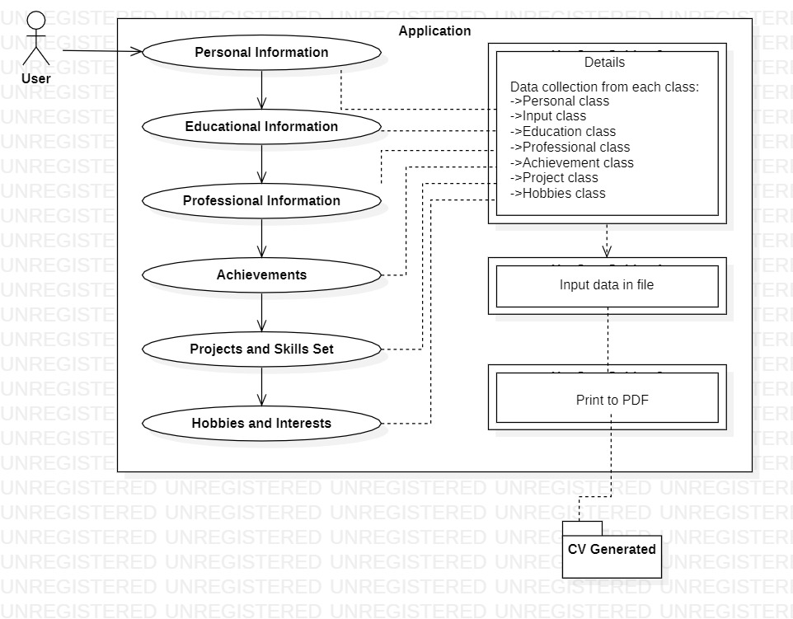

DATA FLOW DIAGRAM
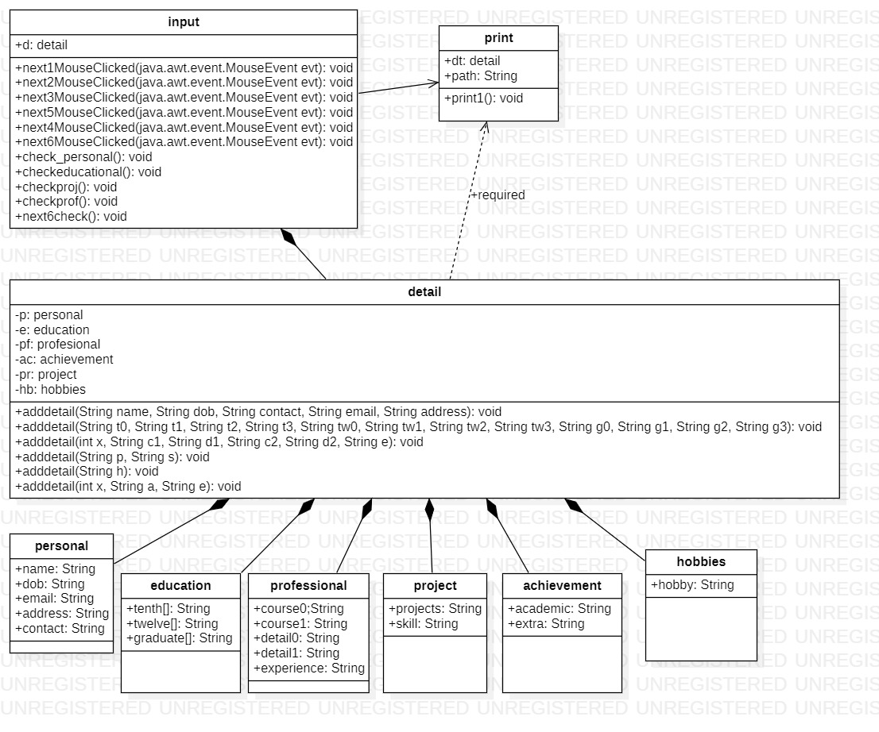
CRC

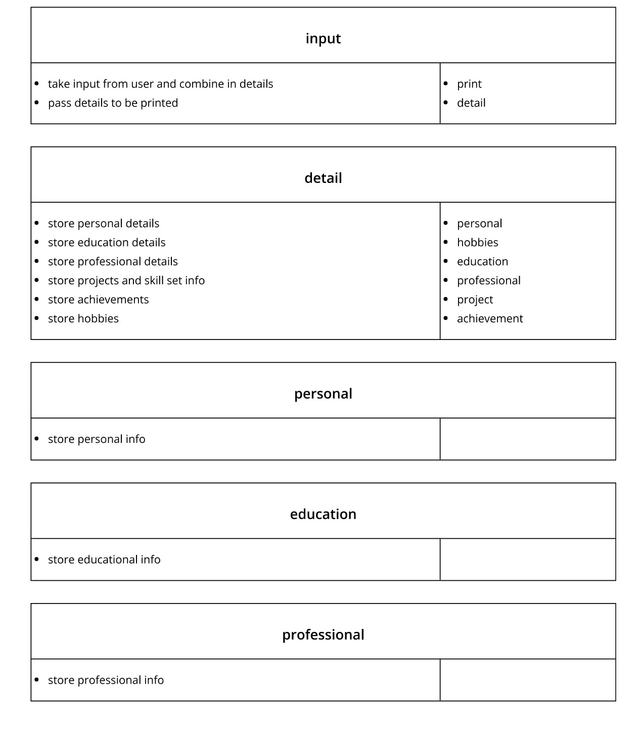
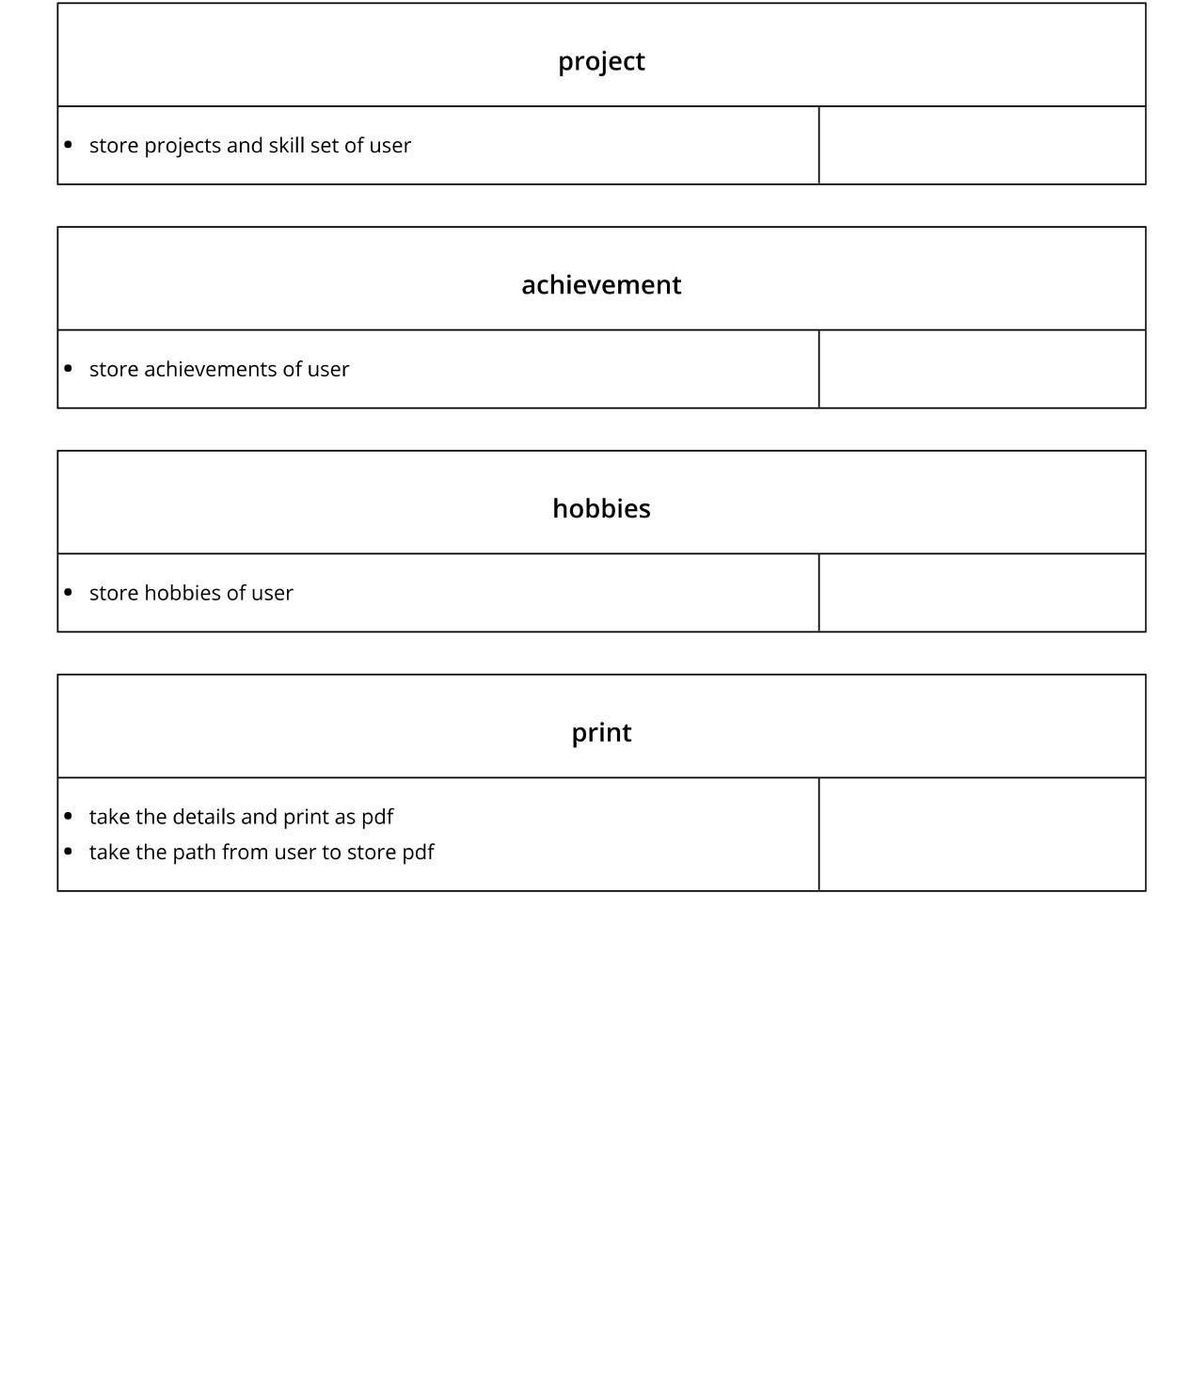

CLASSES
- Personal class
- Input class
- Education class
- Professional class
- Achievement class
- Project class
- Hobbies class

CODING SNAPSHOTS
- Input.java (Main)
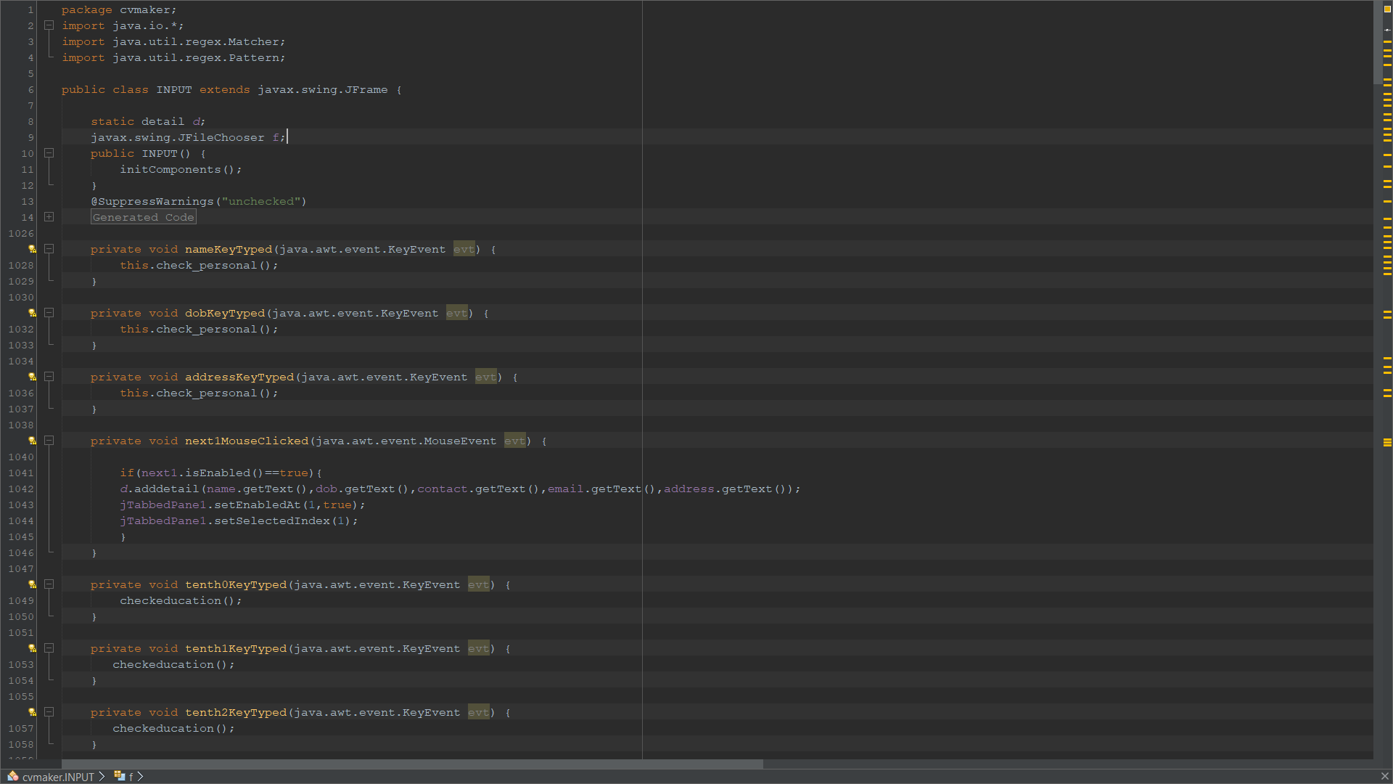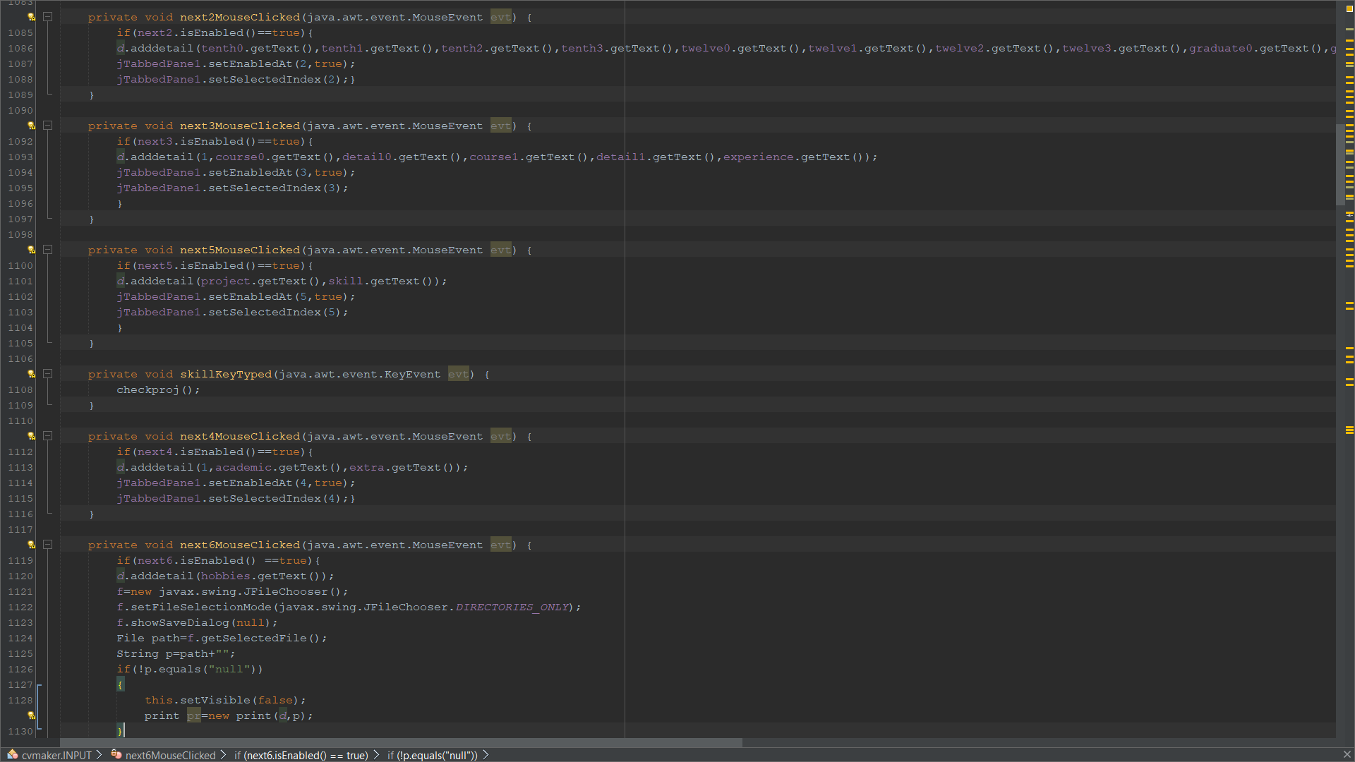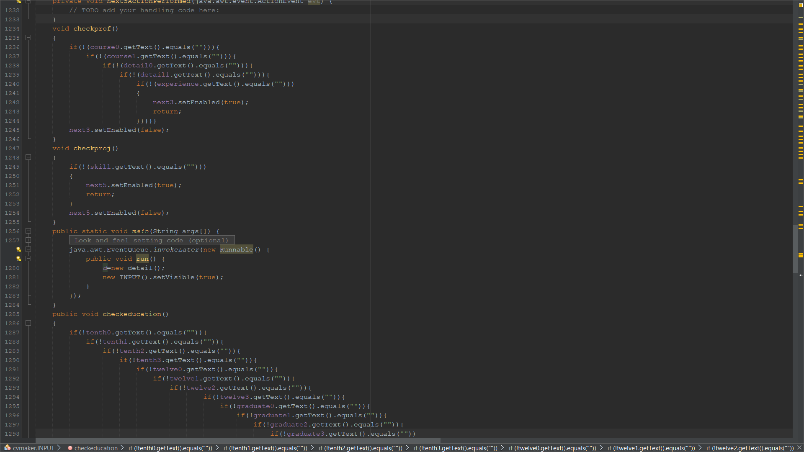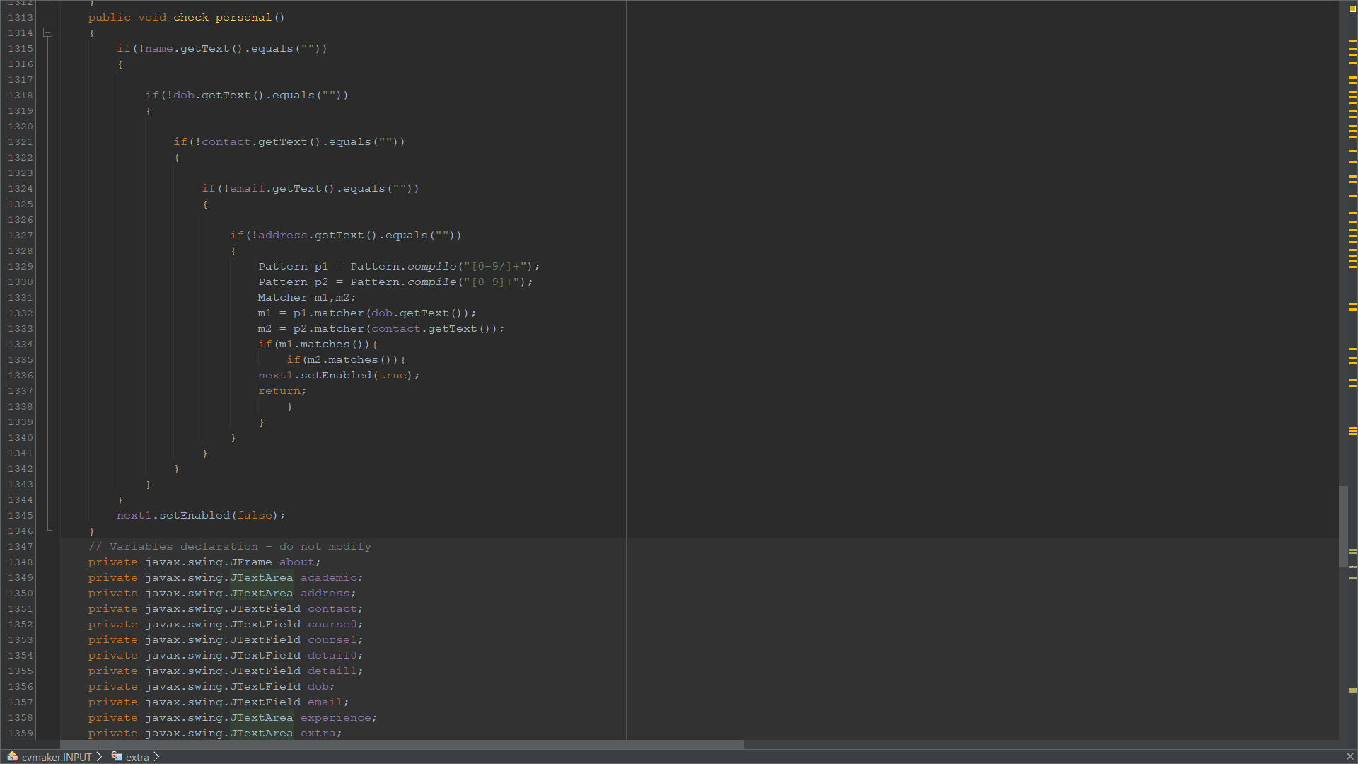

- Detail.java (Class)
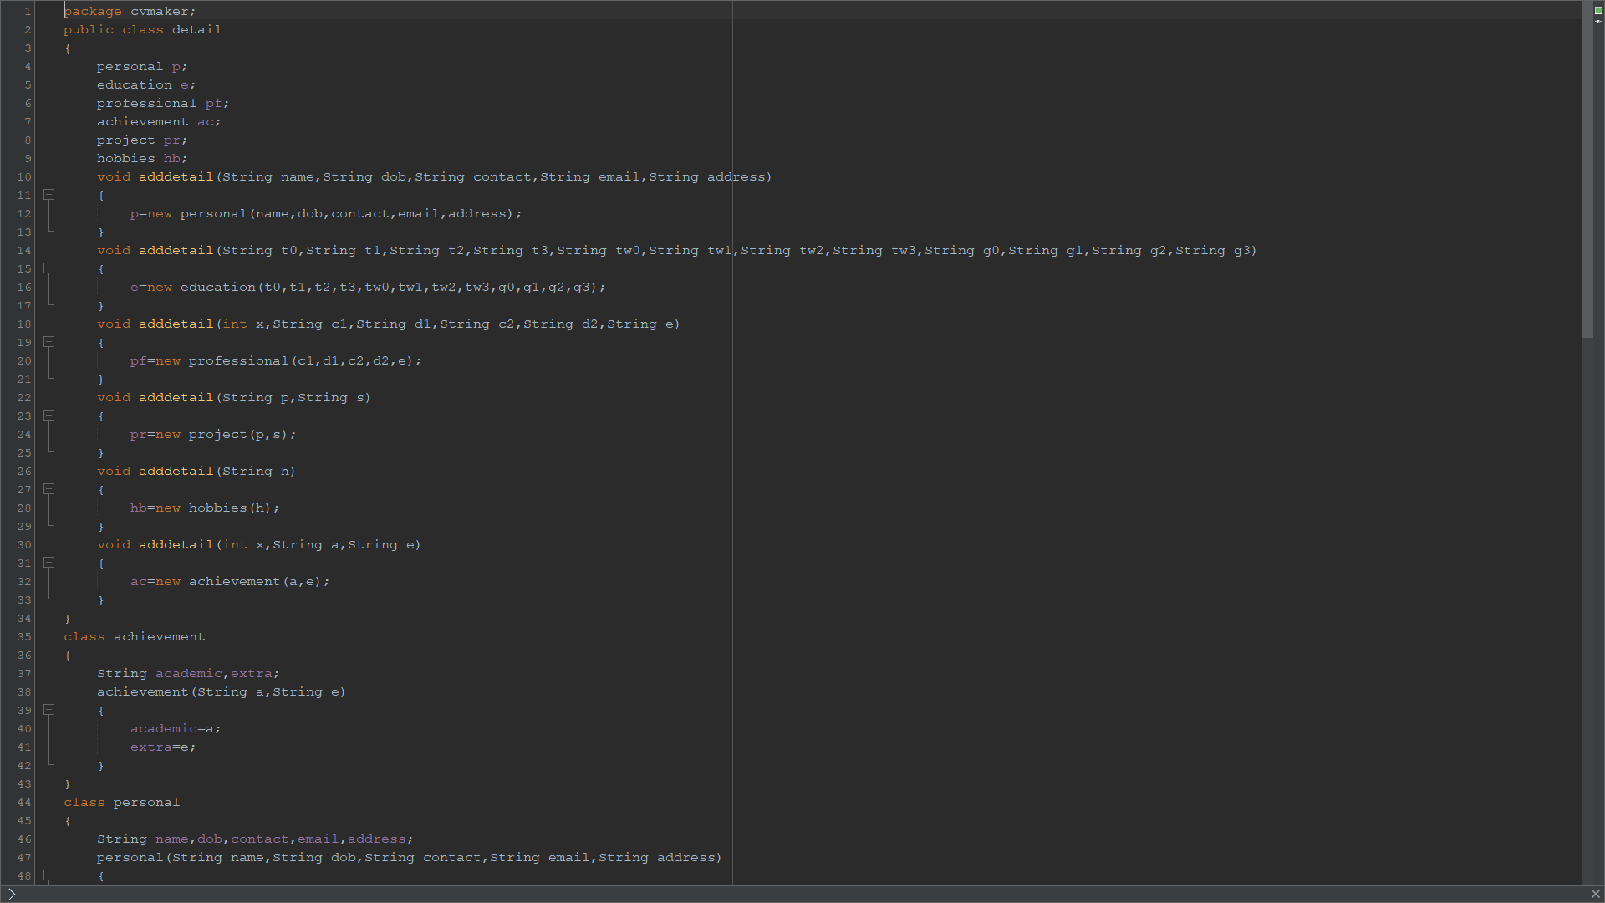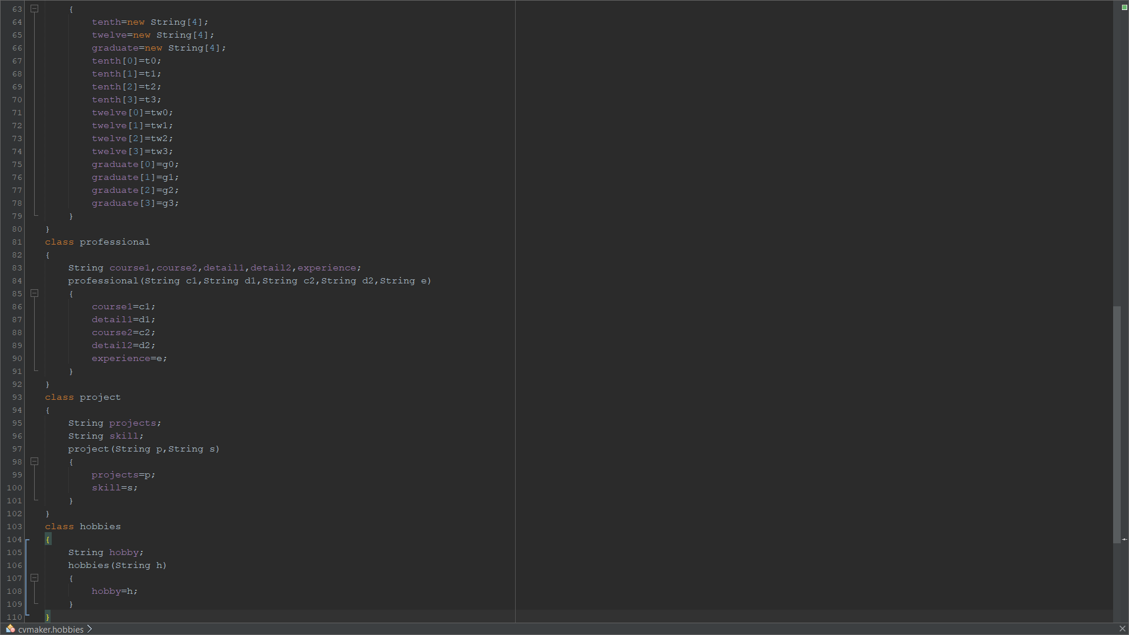
- Print.java (Class)
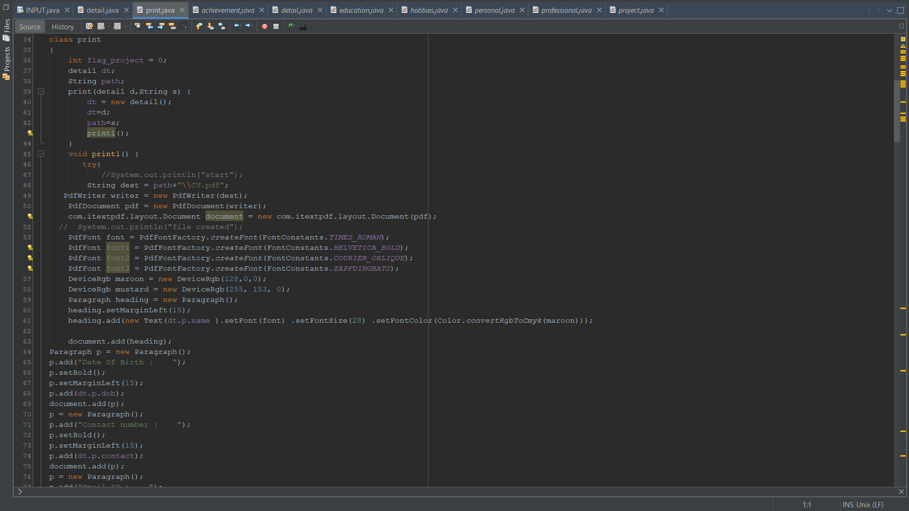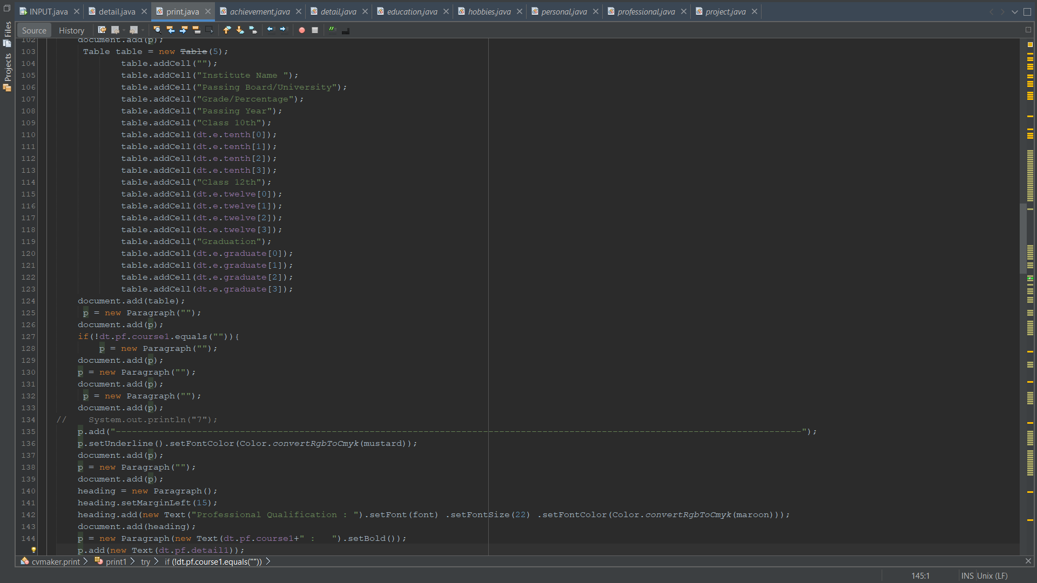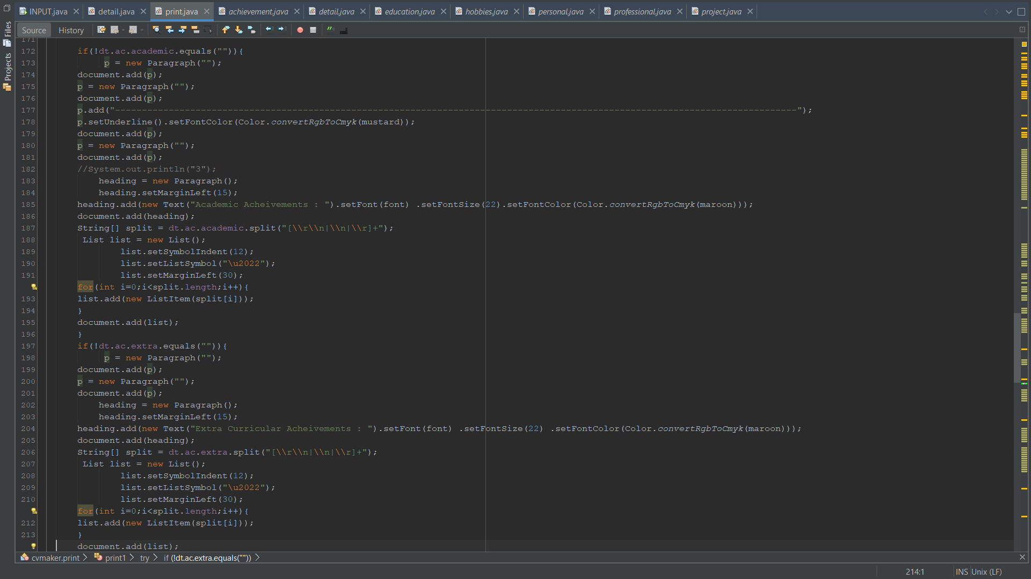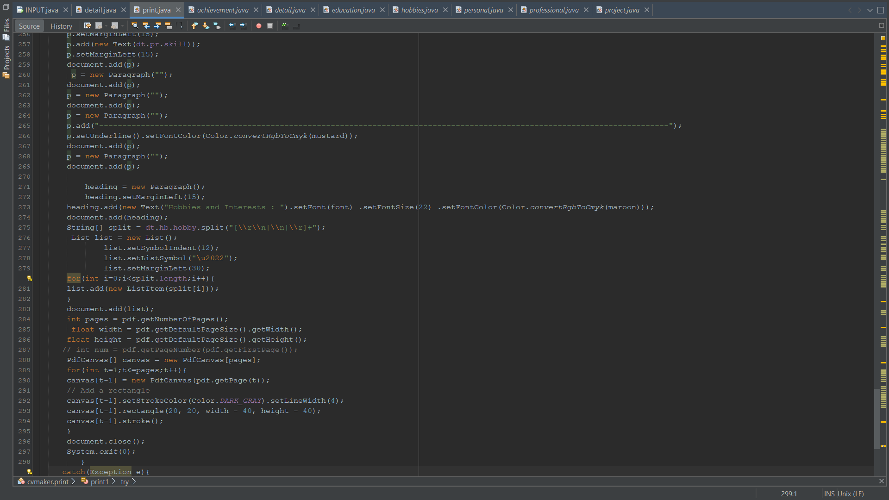
*Note: - For full code refer to the zip file attached

TEST RESULTS
TEST 1:
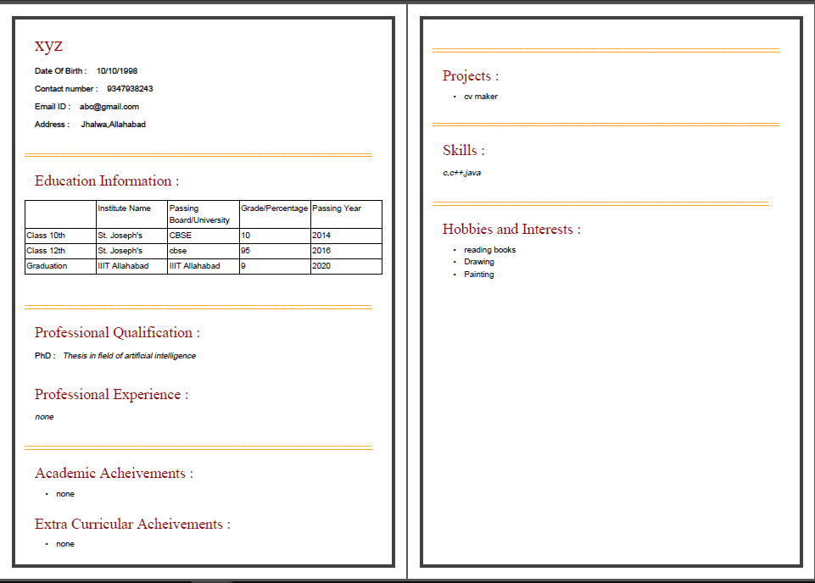

TEST 2:
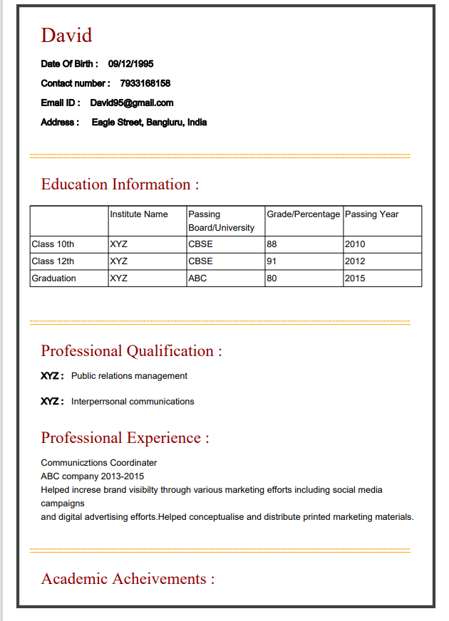
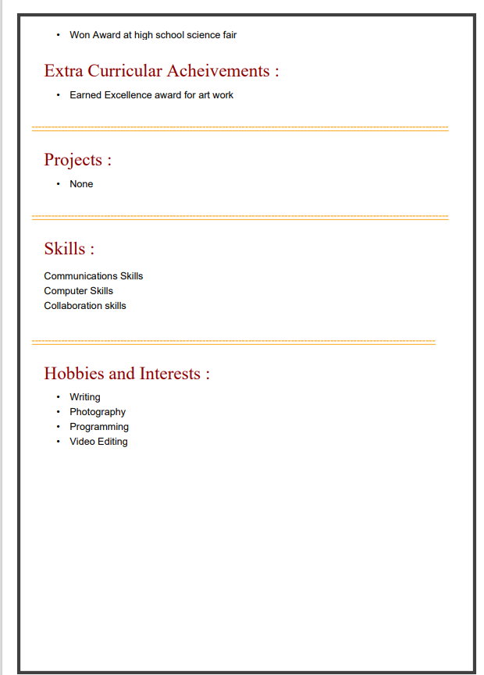

SNAPSHOTS
